Time Series of Global Land and Sea Temperature Anomalies

1880-2017



Time Series-Project 3

David Mammarella

104034574

Dr. Myron Hlynka

65-455-09

***Abstract***:

Climate change has become a major concern in the past few years. Since the mid 1800’s after the industrial revolution there has been worry that the enormous amount of carbon emissions produced by humans has the potential of creating change. There is prospective evidence that this may detrimental to the Earth if these types of emissions continue over the centuries to come. As we know carbon emissions have only increased as industries have flourished and evolved over the years. If it is true that carbon emissions are warming the Earth’s environment this cannot be a good thing. Initiatives have been introduced over recent years to create sustainable energy sources, but these have not been accepted by society as a whole. Proving that that the climate continues to warm, will be shown in the numerous different depictions below. A time series is constructed in this project taking the temperature anomalies away from an averaged value each biannually each year from 1880-2017, present year. From the time series depiction a forecast of future possible values will be predicted based on past temperature anomalies. Using various statistical techniques associated with time series models, it was found that the actual temperature will continue to raise higher by about 2 ° C over the next 2 centuries to come, this was determined from forecasting based on the previous values in the data set.

***Introduction:***

*1. Purpose:*

The purpose of this time series analysis is to take the measured temperature anomalies given in the data set, and display the data in various ways for interpretation. However, the most pressing concern and the main driver of this project was to predict and forecast based on the measured values in the set. This will allow us to make some serious deductions based on what the results are. Being a hot topic of controversy lately, these predictions may very well show that assuming a constant rate that the climate is currently changing, whether we will be better or worse in years to come. Obviously the hope is that climate change is not a concern but that this information will raise may questions pertaining to how the human race lives, treats and uses the many resources the Earth gives us.

*2. Key Aspects:*

The key aspects for this assignment will include mostly visual depictions (i.e plots). A time series of the data set will be the focal point. Then from this, original time series numerous statistical analysis are performed. These analyses begin from a decomposition of the data into a trend, seasonal, and random depiction. The time series will be adjusted in accordance to the trend and seasonal sets. Moving forward, forecasts will be used to determine the future of the data set and time series. The use of simple smoothing, Holt Winters smoothing, as well as ARIMA smoothing techniques will accomplish this.

***Data Characteristics:***

*The data set used:*

|  |  |  |  |
| --- | --- | --- | --- |
| Year | Anomaly (° C) | Year | Anomaly (° C) |
| 1880 | -0.13 | 1962 | 0.17 |
| 1881 | -0.05 | 1963 | 0.26 |
| 1882 | 0.02 | 1964 | -0.1 |
| 1883 | -0.31 | 1965 | -0.19 |
| 1884 | -0.16 | 1966 | -0.04 |
| 1885 | -0.27 | 1967 | -0.16 |
| 1886 | -0.29 | 1968 | -0.13 |
| 1887 | -0.39 | 1969 | -0.1 |
| 1888 | -0.34 | 1970 | 0.24 |
| 1889 | 0 | 1971 | -0.22 |
| 1890 | -0.44 | 1972 | -0.16 |
| 1891 | -0.53 | 1973 | 0.37 |
| 1892 | -0.14 | 1974 | -0.26 |
| 1893 | -0.62 | 1975 | 0.03 |
| 1894 | -0.23 | 1976 | -0.12 |
| 1895 | -0.42 | 1977 | 0.24 |
| 1896 | -0.08 | 1978 | 0.13 |
| 1897 | -0.11 | 1979 | 0.09 |
| 1898 | -0.28 | 1980 | 0.35 |
| 1899 | -0.29 | 1981 | 0.36 |
| 1900 | -0.1 | 1982 | 0.16 |
| 1901 | -0.08 | 1983 | 0.48 |
| 1902 | -0.04 | 1984 | 0.17 |
| 1903 | -0.09 | 1985 | 0.02 |
| 1904 | -0.47 | 1986 | 0.28 |
| 1905 | -0.62 | 1987 | 0.5 |
| 1906 | -0.24 | 1988 | 0.39 |
| 1907 | -0.41 | 1989 | 0.31 |
| 1908 | -0.38 | 1990 | 0.41 |
| 1909 | -0.46 | 1991 | 0.46 |
| 1910 | -0.36 | 1992 | 0.45 |
| 1911 | -0.53 | 1993 | 0.39 |
| 1912 | -0.11 | 1994 | 0.07 |
| 1913 | -0.4 | 1995 | 0.69 |
| 1914 | -0.12 | 1996 | 0.45 |
| 1915 | -0.01 | 1997 | 0.43 |
| 1916 | -0.18 | 1998 | 0.86 |
| 1917 | -0.47 | 1999 | 0.67 |
| 1918 | -0.29 | 2000 | 0.54 |
| 1919 | -0.05 | 2001 | 0.39 |
| 1920 | -0.22 | 2002 | 0.78 |
| 1921 | -0.15 | 2003 | 0.56 |
| 1922 | -0.29 | 2004 | 0.72 |
| 1923 | -0.38 | 2005 | 0.51 |
| 1924 | -0.18 | 2006 | 0.62 |
| 1925 | -0.28 | 2007 | 0.66 |
| 1926 | 0.09 | 2008 | 0.38 |
| 1927 | -0.19 | 2009 | 0.57 |
| 1928 | -0.13 | 2010 | 0.7 |
| 1929 | -0.54 | 2011 | 0.49 |
| 1930 | -0.2 | 2012 | 0.42 |
| 1931 | -0.22 | 2013 | 0.63 |
| 1932 | -0.17 | 2014 | 0.48 |
| 1933 | -0.32 | 2015 | 0.88 |
| 1934 | -0.02 | 2016 | 1.2 |
| 1935 | 0.17 | 2017 | 0.98 |
| 1936 | -0.31 |
| 1937 | 0.04 |
| 1938 | -0.05 |
| 1939 | -0.11 |
| 1940 | 0.06 |
| 1941 | 0.23 |
| 1942 | 0.1 |
| 1943 | 0.17 |
| 1944 | 0.31 |
| 1945 | 0.02 |
| 1946 | 0.09 |
| 1947 | -0.08 |
| 1948 | -0.09 |
| 1949 | -0.15 |
| 1950 | -0.24 |
| 1951 | -0.4 |
| 1952 | 0.1 |
| 1953 | 0.16 |
| 1954 | -0.08 |
| 1955 | -0.13 |
| 1956 | -0.27 |
| 1957 | -0.11 |
| 1958 | 0.21 |
| 1959 | 0.07 |
| 1960 | 0.19 |
| 1961 | 0.18 |

*About the Data Set:*

The data set used is taken from the National Centers for Environmental Information, and are measured globally over the land and sea. As noticed above, temperature anomalies are used instead of an absolute value or an actual value. As made clear on the data website, absolute values are too difficult to accumulate as some regions have difficulties measuring temperatures. Interpolation methods must be used to derive temperatures for from this data. A temperature anomaly means a departure from a long-term average (a reference value). In this project, a negative value indicates that the observed temperature was cooler than the reference, while a positive indicates it was warmer than the reference value.

***Graphical Analysis***

Time Series from Data Set:

This is the time series plotted from the data set used for this project. It includes the temperature anomalies away from the long-term average measured. This data is over the time interval (in years) of 1880 to present day 2017. The warmest years over this time interval are predominately the past decade.

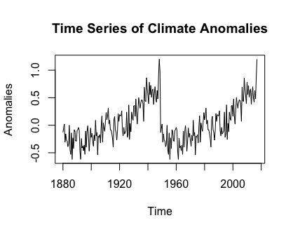

Decomposition of the Time Series:

The time series presented was next decomposed into its 3 components of an additive time series🡪 *Xt* = Trend + Seasonal + Random

Seasonal Portion: patterns that repeat within a fixed period of time; the seasonality with respect to this time series is biannually.

Trend Portion: the underlying trend of the temperature anomalies measured.

Random (Irregular) Portion: the residuals of the time series after allocation into the seasonal and trend portions.

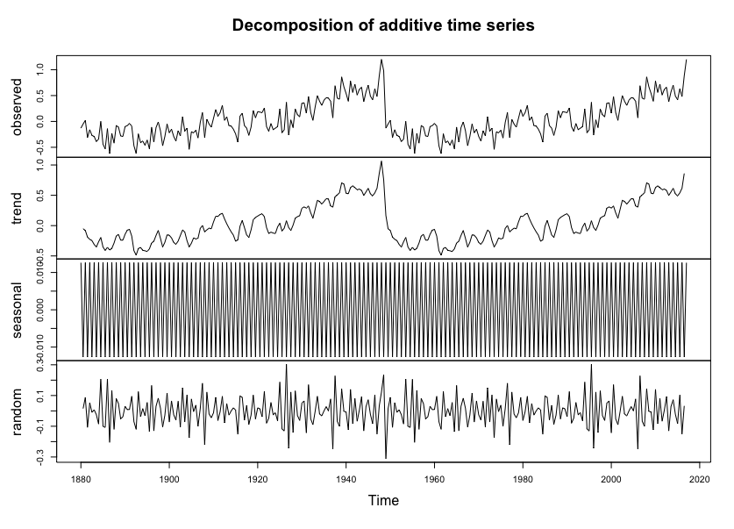

Below is the seasonal adjusted graph and trend adjusted graph. When removing seasonality (seasonally adjusting), this allows us to deal with only the trend and random points in the time series. A trend-adjusted graph is presented here for reference even though seasonality is always present. The same conclusions can be made from it.

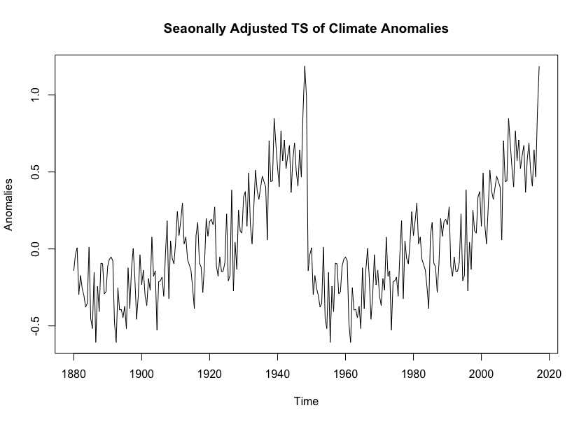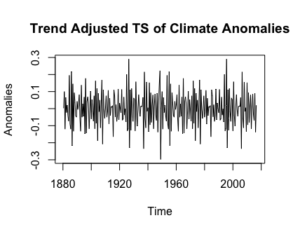

Simple Smoothing:

For reference, a simple smoothing method is employed on the time series. This is as a result of extreme variation that time series often display. Simple smoothing allows the time series to fit closer to a straight line. In these graphs it is by a factor of 8 and 15.

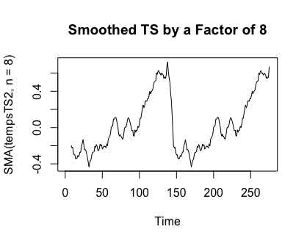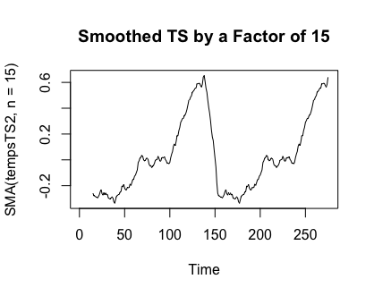

Holt Winters Forecasting:

The Holt-Winter additive model for seasonal smoothing is: yt = β0 +β1t+St +εt

Based on the time series provided, out values are β0 = 0.382062, β1= 0.02262959, and St =0.03074914. This corresponds to the level, trend and seasonality of the time series, respectively. The first graph below shows Holt-Winters filtering, telling us that the model is very good at prediction (red line shows the prediction and black line is original) as they are very similar. To check if the prediction method can be improved upon, we check for non-zero autocorrelations. We use a statistical method called the Ljung-Box Method. As the p-value proves to be 0.005351 and there is 1 autocorrelations exceeding the significance bounds. this tells us that the test is in fact statistical significant. From the QQ-plots and histogram of residuals, we can tell the data is normal, signifying that the forecast variance is constant with a mean of zero. From this we can conclude the Holt-Winters Forecast is an adequate model for this data set.

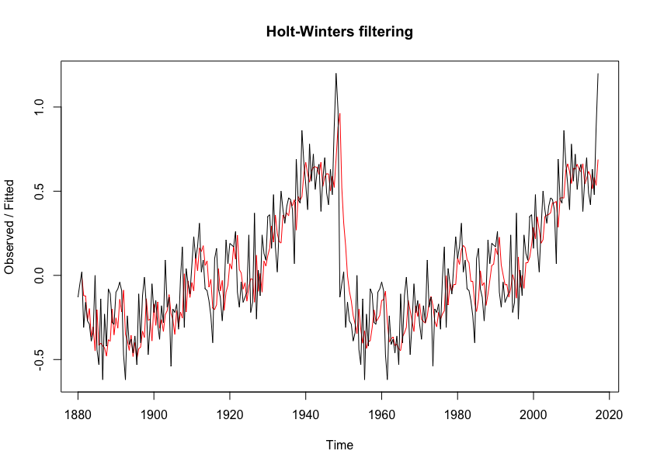

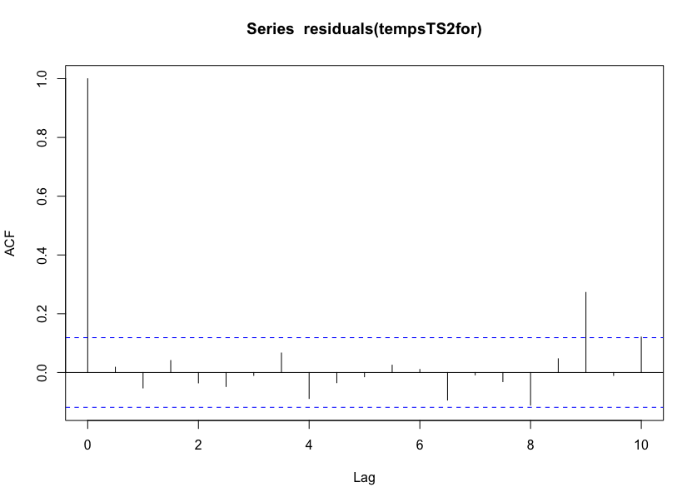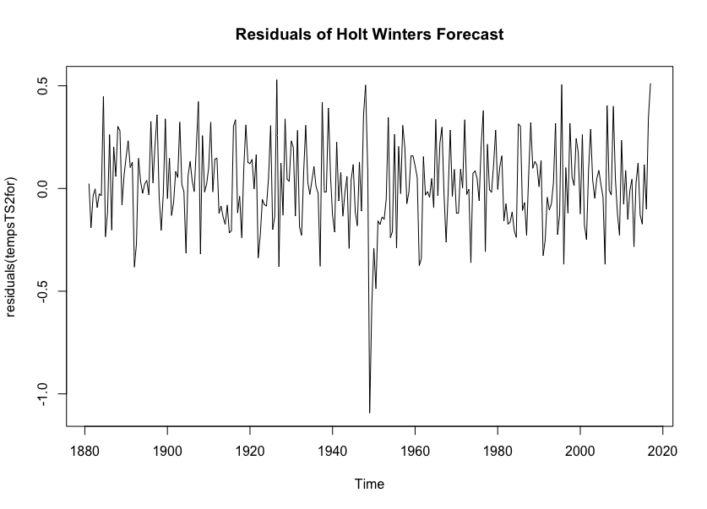

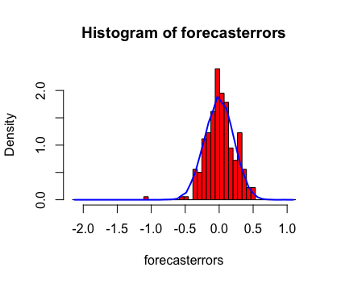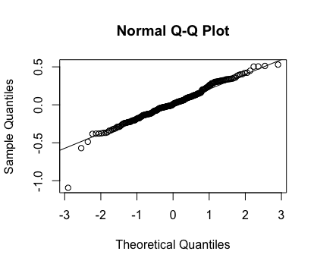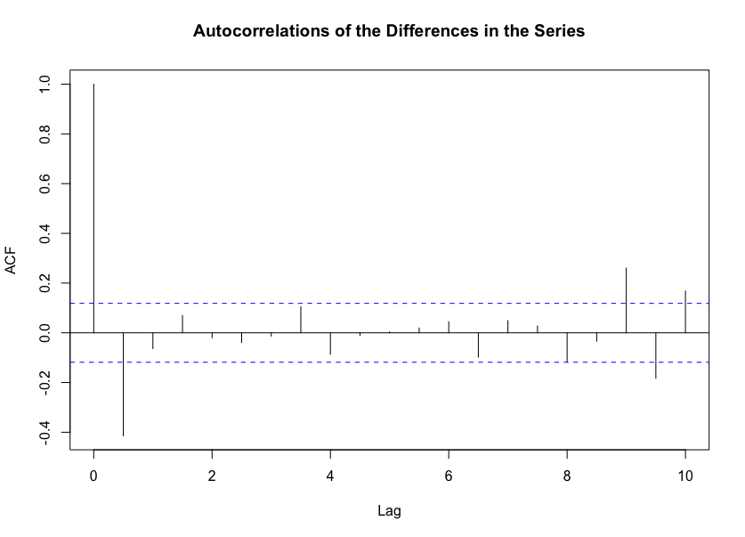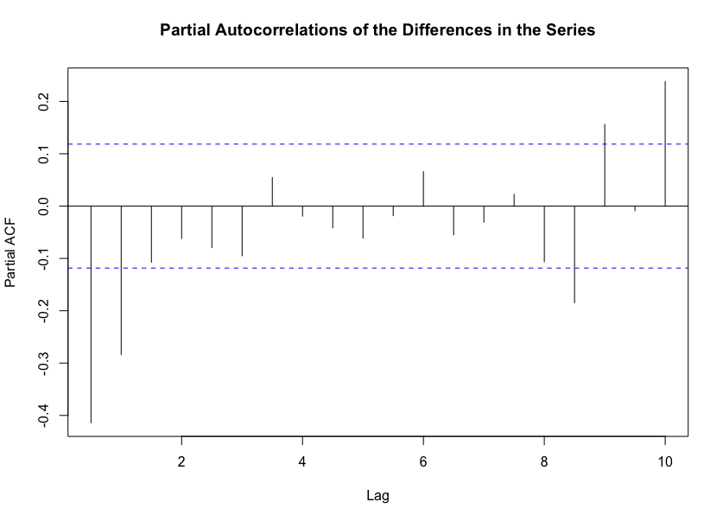

The Holt-Winters exponential smoothing method goes further by taking the data and predicting a slope for “h” years to come. The blue gives a 95% prediction interval and the grey gives 80% prediction interval. Below these graphs gives a magnification of the slope for the future years to come as predicted by the Holt Winters function.

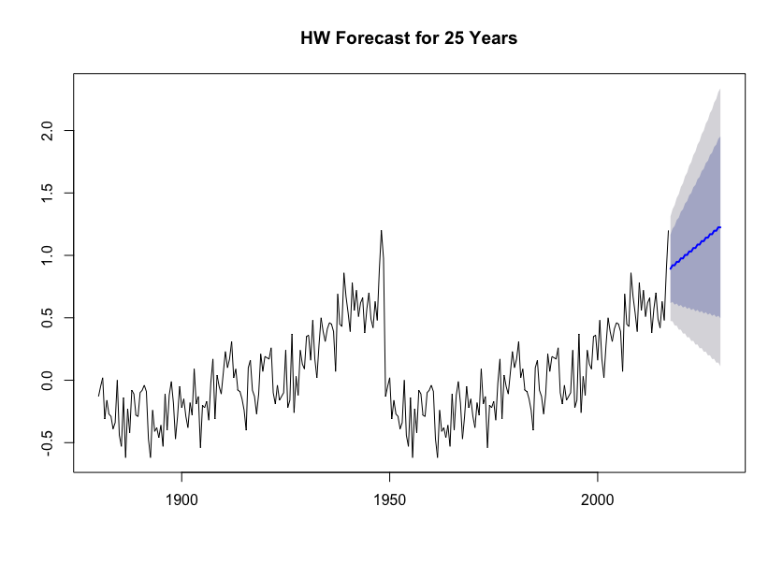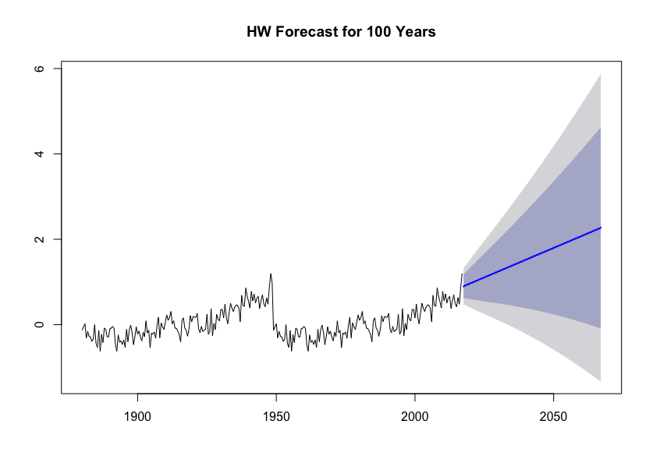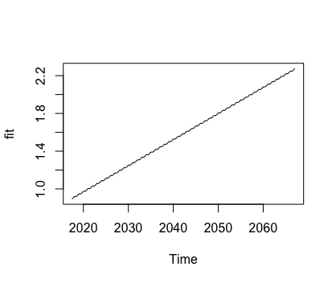

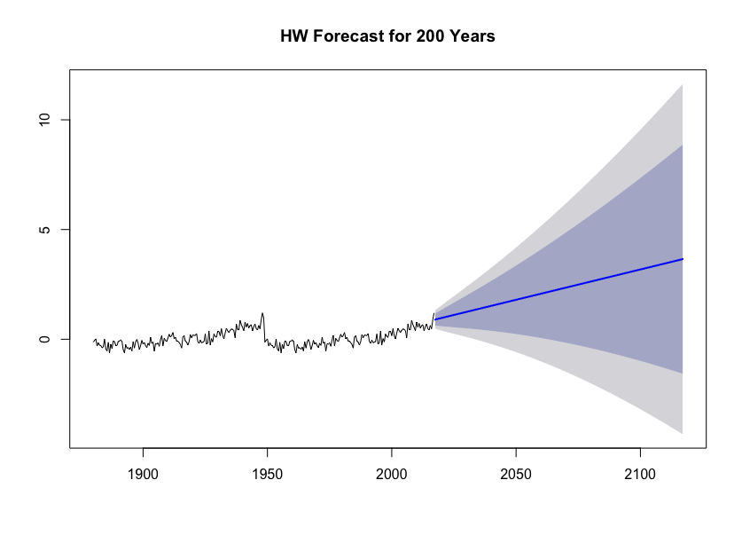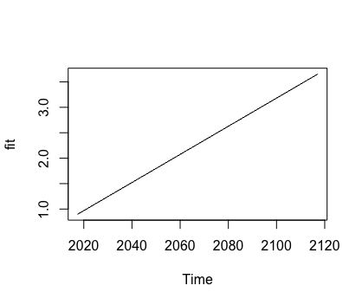

ARIMA Forecasts:

The autoregressive integrated moving average (denoted by ARIMA (p,d,q)) model includes a statistical model for the irregular component of a time series, allowing for the autocorrelations in the irregular (random) component. The model of this nature is defined by: 􏰯yt (B)=β0 +􏰰(B)εt .

First, ARIMA models are described for stationary time series, so that is the first thing that needs to be checked. As the first graph’s stability is debatable, the difference is taken (first graph below), this give us a stable graph to work with. The auto.arima function is used in R to determine the model type and fit the time series accordingly. It turns out the model that fits are ARIMA (0,1,1). The coefficients are -0.6265 and 0. The QQ-plot and histogram show that the variance is constant and distribution is normal.

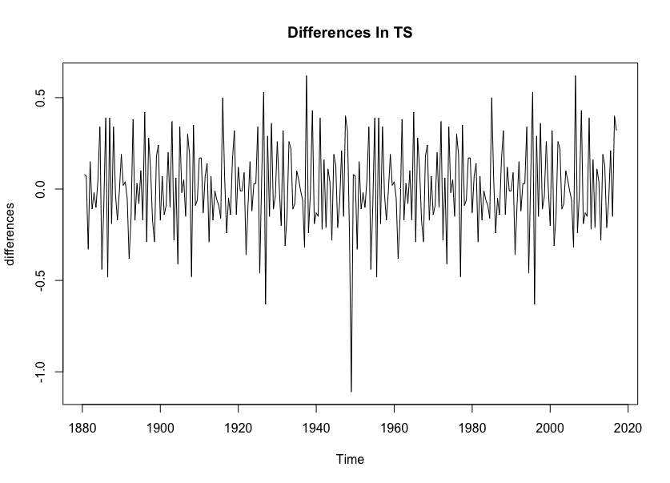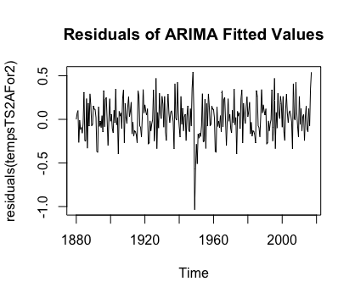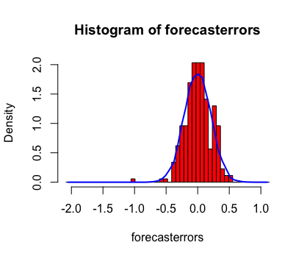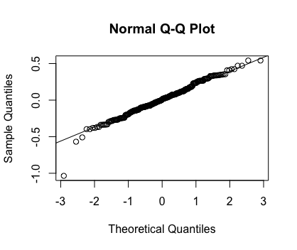

The actual forecast from the ARIMA model was inconsistent in comparison to the Holt Winters Forecast. This forecasts the same colored 95% and 80% prediction interval covering most of the area where there is graph behind it and a straight line with a slope of zero in the middle. This says that the temperature will likely stay the same in the years to come. This seems to be not very consistent with the temperatures previous, proving to be not as satisfactory of a model as the Holt Winters model.

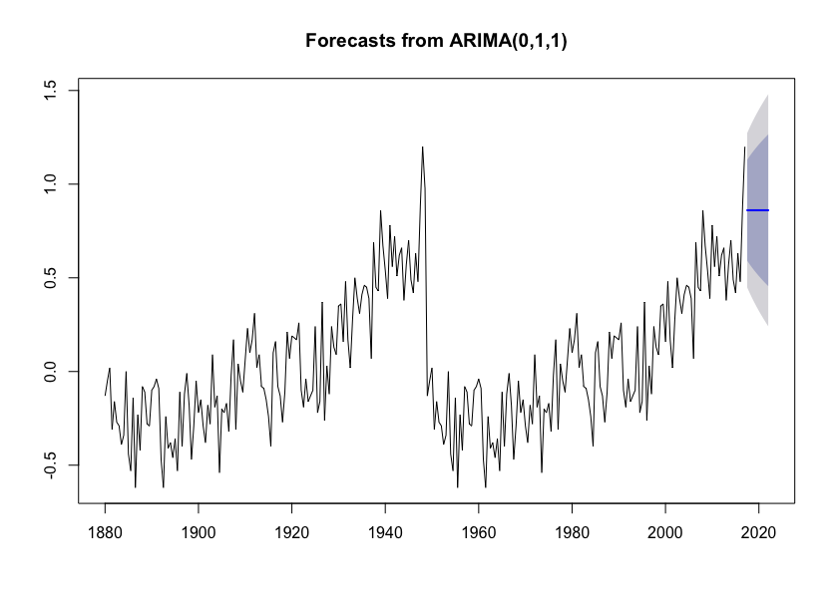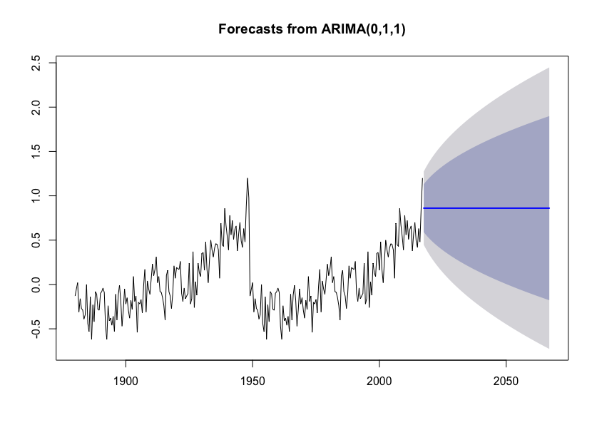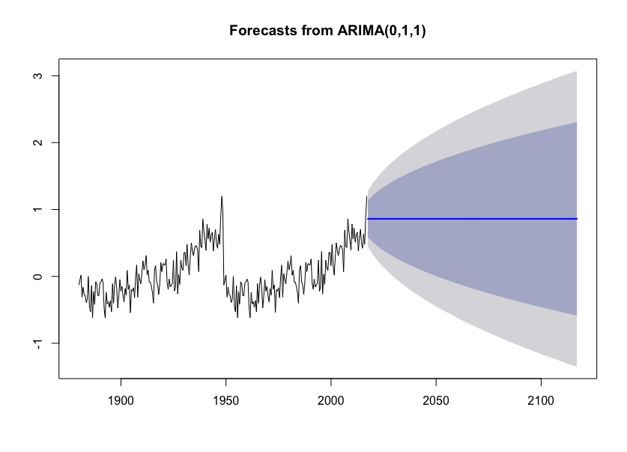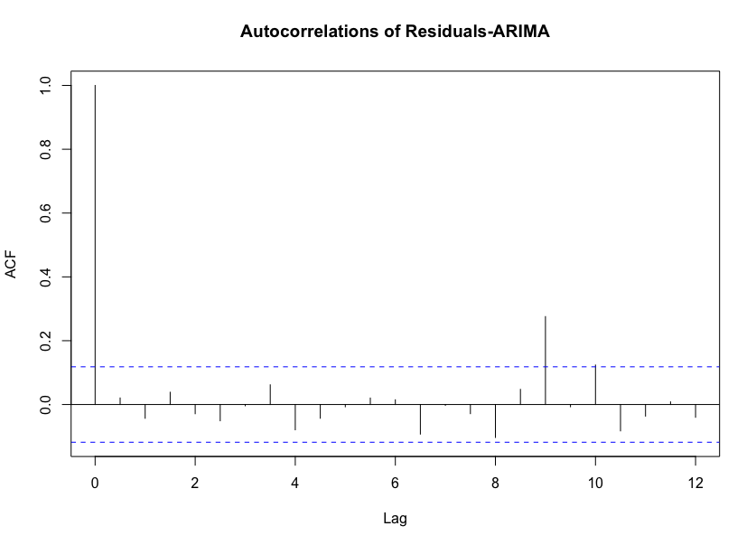

***Other Graphical Output***

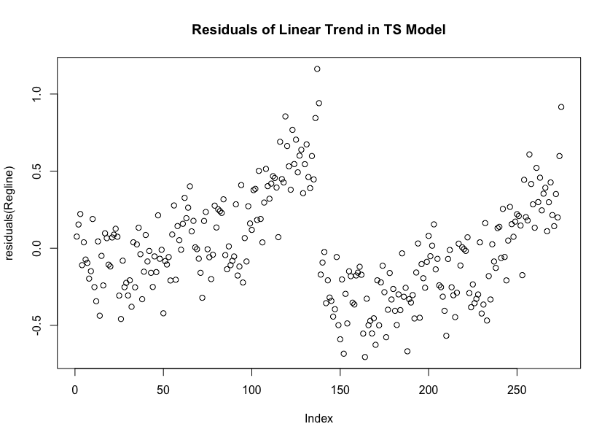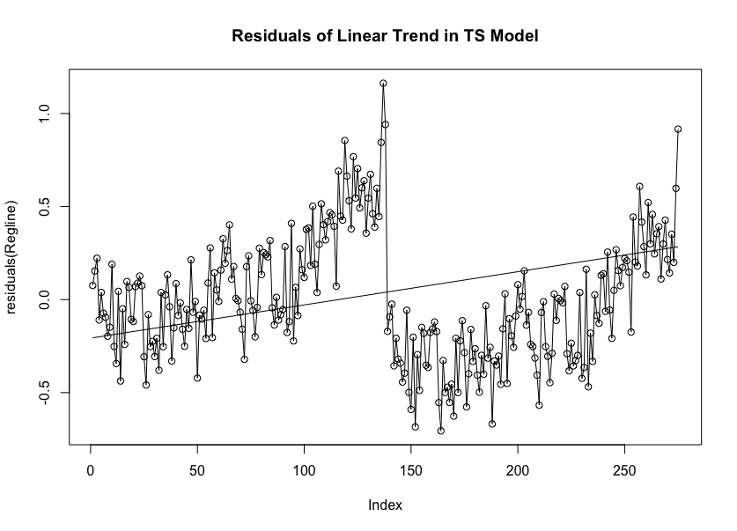

***Conclusion and Final Results***

The aim of this project is to map the previous temperature anomalies globally as a time series and use that information in hand along with various statistical processes as a tool to predict future year temperature anomalies. This is such a pressing task because for various reasons a shift too large in temperature (positively or negatively) could have detrimental effects to the Earth, and as an extension humanity as the inhabitants of the Earth. The Holt-Winters and ARIMA (0,0,1) models are the most accurate to forecast this subject and data set. Furthermore, the Holt-Winters seemed to give the greatest feedback in terms of its model, telling us that global temperatures will increase over 2 ° C over the next 200 years. An increase of 2 ° C does not seem like a lot, but in actuality this is a great amount over the world especially for warmer places in the world. Scientists will have to come together to fully see the effects of this global temperature anomaly change in the future if this model proves to be as accurate as shown in this statistical study.

***R Commands:***

> temps=read.table("/Users/DRMair/Desktop/Year 4 Sem 2/Time Series and Regression-65 455 09/Project 3-Time Series/Data forR.csv", header=FALSE, sep = ",", col.names = c("Anomalies"))

> tempsTS2=ts(temps, start = c(1880,1), end = c(2017,1), frequency = 2)

> plot.ts(tempsTS2)

> tempsTS2

Time Series:

Start = c(1880, 1)

End = c(2017, 1)

Frequency = 2

[1] -0.13 -0.05 0.02 -0.31 -0.16 -0.27 -0.29 -0.39 -0.34 0.00 -0.44

[12] -0.53 -0.14 -0.62 -0.23 -0.42 -0.08 -0.11 -0.28 -0.29 -0.10 -0.08

[23] -0.04 -0.09 -0.47 -0.62 -0.24 -0.41 -0.38 -0.46 -0.36 -0.53 -0.11

[34] -0.40 -0.12 -0.01 -0.18 -0.47 -0.29 -0.05 -0.22 -0.15 -0.29 -0.38

[45] -0.18 -0.28 0.09 -0.19 -0.13 -0.54 -0.20 -0.22 -0.17 -0.32 -0.02

[56] 0.17 -0.31 0.04 -0.05 -0.11 0.06 0.23 0.10 0.17 0.31 0.02

[67] 0.09 -0.08 -0.09 -0.15 -0.24 -0.40 0.10 0.16 -0.08 -0.13 -0.27

[78] -0.11 0.21 0.07 0.19 0.18 0.17 0.26 -0.10 -0.19 -0.04 -0.16

[89] -0.13 -0.10 0.24 -0.22 -0.16 0.37 -0.26 0.03 -0.12 0.24 0.13

[100] 0.09 0.35 0.36 0.16 0.48 0.17 0.02 0.28 0.50 0.39 0.31

[111] 0.41 0.46 0.45 0.39 0.07 0.69 0.45 0.43 0.86 0.67 0.54

[122] 0.39 0.78 0.56 0.72 0.51 0.62 0.66 0.38 0.57 0.70 0.49

[133] 0.42 0.63 0.48 0.88 1.20 0.98 -0.13 -0.05 0.02 -0.31 -0.16

[144] -0.27 -0.29 -0.39 -0.34 0.00 -0.44 -0.53 -0.14 -0.62 -0.23 -0.42

[155] -0.08 -0.11 -0.28 -0.29 -0.10 -0.08 -0.04 -0.09 -0.47 -0.62 -0.24

[166] -0.41 -0.38 -0.46 -0.36 -0.53 -0.11 -0.40 -0.12 -0.01 -0.18 -0.47

[177] -0.29 -0.05 -0.22 -0.15 -0.29 -0.38 -0.18 -0.28 0.09 -0.19 -0.13

[188] -0.54 -0.20 -0.22 -0.17 -0.32 -0.02 0.17 -0.31 0.04 -0.05 -0.11

[199] 0.06 0.23 0.10 0.17 0.31 0.02 0.09 -0.08 -0.09 -0.15 -0.24

[210] -0.40 0.10 0.16 -0.08 -0.13 -0.27 -0.11 0.21 0.07 0.19 0.18

[221] 0.17 0.26 -0.10 -0.19 -0.04 -0.16 -0.13 -0.10 0.24 -0.22 -0.16

[232] 0.37 -0.26 0.03 -0.12 0.24 0.13 0.09 0.35 0.36 0.16 0.48

[243] 0.17 0.02 0.28 0.50 0.39 0.31 0.41 0.46 0.45 0.39 0.07

[254] 0.69 0.45 0.43 0.86 0.67 0.54 0.39 0.78 0.56 0.72 0.51

[265] 0.62 0.66 0.38 0.57 0.70 0.49 0.42 0.63 0.48 0.88 1.20

> decompose(tempsTS2)

$x

Time Series:

Start = c(1880, 1)

End = c(2017, 1)

Frequency = 2

[1] -0.13 -0.05 0.02 -0.31 -0.16 -0.27 -0.29 -0.39 -0.34 0.00 -0.44

[12] -0.53 -0.14 -0.62 -0.23 -0.42 -0.08 -0.11 -0.28 -0.29 -0.10 -0.08

[23] -0.04 -0.09 -0.47 -0.62 -0.24 -0.41 -0.38 -0.46 -0.36 -0.53 -0.11

[34] -0.40 -0.12 -0.01 -0.18 -0.47 -0.29 -0.05 -0.22 -0.15 -0.29 -0.38

[45] -0.18 -0.28 0.09 -0.19 -0.13 -0.54 -0.20 -0.22 -0.17 -0.32 -0.02

[56] 0.17 -0.31 0.04 -0.05 -0.11 0.06 0.23 0.10 0.17 0.31 0.02

[67] 0.09 -0.08 -0.09 -0.15 -0.24 -0.40 0.10 0.16 -0.08 -0.13 -0.27

[78] -0.11 0.21 0.07 0.19 0.18 0.17 0.26 -0.10 -0.19 -0.04 -0.16

[89] -0.13 -0.10 0.24 -0.22 -0.16 0.37 -0.26 0.03 -0.12 0.24 0.13

[100] 0.09 0.35 0.36 0.16 0.48 0.17 0.02 0.28 0.50 0.39 0.31

[111] 0.41 0.46 0.45 0.39 0.07 0.69 0.45 0.43 0.86 0.67 0.54

[122] 0.39 0.78 0.56 0.72 0.51 0.62 0.66 0.38 0.57 0.70 0.49

[133] 0.42 0.63 0.48 0.88 1.20 0.98 -0.13 -0.05 0.02 -0.31 -0.16

[144] -0.27 -0.29 -0.39 -0.34 0.00 -0.44 -0.53 -0.14 -0.62 -0.23 -0.42

[155] -0.08 -0.11 -0.28 -0.29 -0.10 -0.08 -0.04 -0.09 -0.47 -0.62 -0.24

[166] -0.41 -0.38 -0.46 -0.36 -0.53 -0.11 -0.40 -0.12 -0.01 -0.18 -0.47

[177] -0.29 -0.05 -0.22 -0.15 -0.29 -0.38 -0.18 -0.28 0.09 -0.19 -0.13

[188] -0.54 -0.20 -0.22 -0.17 -0.32 -0.02 0.17 -0.31 0.04 -0.05 -0.11

[199] 0.06 0.23 0.10 0.17 0.31 0.02 0.09 -0.08 -0.09 -0.15 -0.24

[210] -0.40 0.10 0.16 -0.08 -0.13 -0.27 -0.11 0.21 0.07 0.19 0.18

[221] 0.17 0.26 -0.10 -0.19 -0.04 -0.16 -0.13 -0.10 0.24 -0.22 -0.16

[232] 0.37 -0.26 0.03 -0.12 0.24 0.13 0.09 0.35 0.36 0.16 0.48

[243] 0.17 0.02 0.28 0.50 0.39 0.31 0.41 0.46 0.45 0.39 0.07

[254] 0.69 0.45 0.43 0.86 0.67 0.54 0.39 0.78 0.56 0.72 0.51

[265] 0.62 0.66 0.38 0.57 0.70 0.49 0.42 0.63 0.48 0.88 1.20

$seasonal

Time Series:

Start = c(1880, 1)

End = c(2017, 1)

Frequency = 2

[1] 0.01261841 -0.01261841 0.01261841 -0.01261841 0.01261841

[6] -0.01261841 0.01261841 -0.01261841 0.01261841 -0.01261841

[11] 0.01261841 -0.01261841 0.01261841 -0.01261841 0.01261841

[16] -0.01261841 0.01261841 -0.01261841 0.01261841 -0.01261841

[21] 0.01261841 -0.01261841 0.01261841 -0.01261841 0.01261841

[26] -0.01261841 0.01261841 -0.01261841 0.01261841 -0.01261841

[31] 0.01261841 -0.01261841 0.01261841 -0.01261841 0.01261841

[36] -0.01261841 0.01261841 -0.01261841 0.01261841 -0.01261841

[41] 0.01261841 -0.01261841 0.01261841 -0.01261841 0.01261841

[46] -0.01261841 0.01261841 -0.01261841 0.01261841 -0.01261841

[51] 0.01261841 -0.01261841 0.01261841 -0.01261841 0.01261841

[56] -0.01261841 0.01261841 -0.01261841 0.01261841 -0.01261841

[61] 0.01261841 -0.01261841 0.01261841 -0.01261841 0.01261841

[66] -0.01261841 0.01261841 -0.01261841 0.01261841 -0.01261841

[71] 0.01261841 -0.01261841 0.01261841 -0.01261841 0.01261841

[76] -0.01261841 0.01261841 -0.01261841 0.01261841 -0.01261841

[81] 0.01261841 -0.01261841 0.01261841 -0.01261841 0.01261841

[86] -0.01261841 0.01261841 -0.01261841 0.01261841 -0.01261841

[91] 0.01261841 -0.01261841 0.01261841 -0.01261841 0.01261841

[96] -0.01261841 0.01261841 -0.01261841 0.01261841 -0.01261841

[101] 0.01261841 -0.01261841 0.01261841 -0.01261841 0.01261841

[106] -0.01261841 0.01261841 -0.01261841 0.01261841 -0.01261841

[111] 0.01261841 -0.01261841 0.01261841 -0.01261841 0.01261841

[116] -0.01261841 0.01261841 -0.01261841 0.01261841 -0.01261841

[121] 0.01261841 -0.01261841 0.01261841 -0.01261841 0.01261841

[126] -0.01261841 0.01261841 -0.01261841 0.01261841 -0.01261841

[131] 0.01261841 -0.01261841 0.01261841 -0.01261841 0.01261841

[136] -0.01261841 0.01261841 -0.01261841 0.01261841 -0.01261841

[141] 0.01261841 -0.01261841 0.01261841 -0.01261841 0.01261841

[146] -0.01261841 0.01261841 -0.01261841 0.01261841 -0.01261841

[151] 0.01261841 -0.01261841 0.01261841 -0.01261841 0.01261841

[156] -0.01261841 0.01261841 -0.01261841 0.01261841 -0.01261841

[161] 0.01261841 -0.01261841 0.01261841 -0.01261841 0.01261841

[166] -0.01261841 0.01261841 -0.01261841 0.01261841 -0.01261841

[171] 0.01261841 -0.01261841 0.01261841 -0.01261841 0.01261841

[176] -0.01261841 0.01261841 -0.01261841 0.01261841 -0.01261841

[181] 0.01261841 -0.01261841 0.01261841 -0.01261841 0.01261841

[186] -0.01261841 0.01261841 -0.01261841 0.01261841 -0.01261841

[191] 0.01261841 -0.01261841 0.01261841 -0.01261841 0.01261841

[196] -0.01261841 0.01261841 -0.01261841 0.01261841 -0.01261841

[201] 0.01261841 -0.01261841 0.01261841 -0.01261841 0.01261841

[206] -0.01261841 0.01261841 -0.01261841 0.01261841 -0.01261841

[211] 0.01261841 -0.01261841 0.01261841 -0.01261841 0.01261841

[216] -0.01261841 0.01261841 -0.01261841 0.01261841 -0.01261841

[221] 0.01261841 -0.01261841 0.01261841 -0.01261841 0.01261841

[226] -0.01261841 0.01261841 -0.01261841 0.01261841 -0.01261841

[231] 0.01261841 -0.01261841 0.01261841 -0.01261841 0.01261841

[236] -0.01261841 0.01261841 -0.01261841 0.01261841 -0.01261841

[241] 0.01261841 -0.01261841 0.01261841 -0.01261841 0.01261841

[246] -0.01261841 0.01261841 -0.01261841 0.01261841 -0.01261841

[251] 0.01261841 -0.01261841 0.01261841 -0.01261841 0.01261841

[256] -0.01261841 0.01261841 -0.01261841 0.01261841 -0.01261841

[261] 0.01261841 -0.01261841 0.01261841 -0.01261841 0.01261841

[266] -0.01261841 0.01261841 -0.01261841 0.01261841 -0.01261841

[271] 0.01261841 -0.01261841 0.01261841 -0.01261841 0.01261841

$trend

Time Series:

Start = c(1880, 1)

End = c(2017, 1)

Frequency = 2

[1] NA -0.0525 -0.0800 -0.1900 -0.2250 -0.2475 -0.3100 -0.3525

[9] -0.2675 -0.1950 -0.3525 -0.4100 -0.3575 -0.4025 -0.3750 -0.2875

[17] -0.1725 -0.1450 -0.2400 -0.2400 -0.1425 -0.0750 -0.0625 -0.1725

[25] -0.4125 -0.4875 -0.3775 -0.3600 -0.4075 -0.4150 -0.4275 -0.3825

[33] -0.2875 -0.2575 -0.1625 -0.0800 -0.2100 -0.3525 -0.2750 -0.1525

[41] -0.1600 -0.2025 -0.2775 -0.3075 -0.2550 -0.1625 -0.0725 -0.1050

[49] -0.2475 -0.3525 -0.2900 -0.2025 -0.2200 -0.2075 -0.0475 0.0025

[57] -0.1025 -0.0700 -0.0425 -0.0525 0.0600 0.1550 0.1500 0.1875

[65] 0.2025 0.1100 0.0300 -0.0400 -0.1025 -0.1575 -0.2575 -0.2350

[73] -0.0100 0.0850 -0.0325 -0.1525 -0.1950 -0.0700 0.0950 0.1350

[81] 0.1575 0.1800 0.1950 0.1475 -0.0325 -0.1300 -0.1075 -0.1225

[89] -0.1300 -0.0225 0.0400 -0.0900 -0.0425 0.0800 -0.0300 -0.0800

[97] 0.0075 0.1225 0.1475 0.1650 0.2875 0.3075 0.2900 0.3225

[105] 0.2100 0.1225 0.2700 0.4175 0.3975 0.3550 0.3975 0.4450

[113] 0.4375 0.3250 0.3050 0.4750 0.5050 0.5425 0.7050 0.6850

[121] 0.5350 0.5250 0.6275 0.6550 0.6275 0.5900 0.6025 0.5800

[129] 0.4975 0.5550 0.6150 0.5250 0.4900 0.5400 0.6175 0.8600

[137] 1.0650 0.7575 0.1675 -0.0525 -0.0800 -0.1900 -0.2250 -0.2475

[145] -0.3100 -0.3525 -0.2675 -0.1950 -0.3525 -0.4100 -0.3575 -0.4025

[153] -0.3750 -0.2875 -0.1725 -0.1450 -0.2400 -0.2400 -0.1425 -0.0750

[161] -0.0625 -0.1725 -0.4125 -0.4875 -0.3775 -0.3600 -0.4075 -0.4150

[169] -0.4275 -0.3825 -0.2875 -0.2575 -0.1625 -0.0800 -0.2100 -0.3525

[177] -0.2750 -0.1525 -0.1600 -0.2025 -0.2775 -0.3075 -0.2550 -0.1625

[185] -0.0725 -0.1050 -0.2475 -0.3525 -0.2900 -0.2025 -0.2200 -0.2075

[193] -0.0475 0.0025 -0.1025 -0.0700 -0.0425 -0.0525 0.0600 0.1550

[201] 0.1500 0.1875 0.2025 0.1100 0.0300 -0.0400 -0.1025 -0.1575

[209] -0.2575 -0.2350 -0.0100 0.0850 -0.0325 -0.1525 -0.1950 -0.0700

[217] 0.0950 0.1350 0.1575 0.1800 0.1950 0.1475 -0.0325 -0.1300

[225] -0.1075 -0.1225 -0.1300 -0.0225 0.0400 -0.0900 -0.0425 0.0800

[233] -0.0300 -0.0800 0.0075 0.1225 0.1475 0.1650 0.2875 0.3075

[241] 0.2900 0.3225 0.2100 0.1225 0.2700 0.4175 0.3975 0.3550

[249] 0.3975 0.4450 0.4375 0.3250 0.3050 0.4750 0.5050 0.5425

[257] 0.7050 0.6850 0.5350 0.5250 0.6275 0.6550 0.6275 0.5900

[265] 0.6025 0.5800 0.4975 0.5550 0.6150 0.5250 0.4900 0.5400

[273] 0.6175 0.8600 NA

$random

Time Series:

Start = c(1880, 1)

End = c(2017, 1)

Frequency = 2

[1] NA 0.0151184119 0.0873815881 -0.1073815881 0.0523815881

[6] -0.0098815881 0.0073815881 -0.0248815881 -0.0851184119 0.2076184119

[11] -0.1001184119 -0.1073815881 0.2048815881 -0.2048815881 0.1323815881

[16] -0.1198815881 0.0798815881 0.0476184119 -0.0526184119 -0.0373815881

[21] 0.0298815881 0.0076184119 0.0098815881 0.0951184119 -0.0701184119

[26] -0.1198815881 0.1248815881 -0.0373815881 0.0148815881 -0.0323815881

[31] 0.0548815881 -0.1348815881 0.1648815881 -0.1298815881 0.0298815881

[36] 0.0826184119 0.0173815881 -0.1048815881 -0.0276184119 0.1151184119

[41] -0.0726184119 0.0651184119 -0.0251184119 -0.0598815881 0.0623815881

[46] -0.1048815881 0.1498815881 -0.0723815881 0.1048815881 -0.1748815881

[51] 0.0773815881 -0.0048815881 0.0373815881 -0.0998815881 0.0148815881

[56] 0.1801184119 -0.2201184119 0.1226184119 -0.0201184119 -0.0448815881

[61] -0.0126184119 0.0876184119 -0.0626184119 -0.0048815881 0.0948815881

[66] -0.0773815881 0.0473815881 -0.0273815881 -0.0001184119 0.0201184119

[71] 0.0048815881 -0.1523815881 0.0973815881 0.0876184119 -0.0601184119

[76] 0.0351184119 -0.0876184119 -0.0273815881 0.1023815881 -0.0523815881

[81] 0.0198815881 0.0126184119 -0.0376184119 0.1251184119 -0.0801184119

[86] -0.0473815881 0.0548815881 -0.0248815881 -0.0126184119 -0.0648815881

[91] 0.1873815881 -0.1173815881 -0.1301184119 0.3026184119 -0.2426184119

[96] 0.1226184119 -0.1401184119 0.1301184119 -0.0301184119 -0.0623815881

[101] 0.0498815881 0.0651184119 -0.1426184119 0.1701184119 -0.0526184119

[106] -0.0898815881 -0.0026184119 0.0951184119 -0.0201184119 -0.0323815881

[111] -0.0001184119 0.0276184119 -0.0001184119 0.0776184119 -0.2476184119

[116] 0.2276184119 -0.0676184119 -0.0998815881 0.1423815881 -0.0023815881

[121] -0.0076184119 -0.1223815881 0.1398815881 -0.0823815881 0.0798815881

[126] -0.0673815881 0.0048815881 0.0926184119 -0.1301184119 0.0276184119

[131] 0.0723815881 -0.0223815881 -0.0826184119 0.1026184119 -0.1501184119

[136] 0.0326184119 0.1223815881 0.2351184119 -0.3101184119 0.0151184119

[141] 0.0873815881 -0.1073815881 0.0523815881 -0.0098815881 0.0073815881

[146] -0.0248815881 -0.0851184119 0.2076184119 -0.1001184119 -0.1073815881

[151] 0.2048815881 -0.2048815881 0.1323815881 -0.1198815881 0.0798815881

[156] 0.0476184119 -0.0526184119 -0.0373815881 0.0298815881 0.0076184119

[161] 0.0098815881 0.0951184119 -0.0701184119 -0.1198815881 0.1248815881

[166] -0.0373815881 0.0148815881 -0.0323815881 0.0548815881 -0.1348815881

[171] 0.1648815881 -0.1298815881 0.0298815881 0.0826184119 0.0173815881

[176] -0.1048815881 -0.0276184119 0.1151184119 -0.0726184119 0.0651184119

[181] -0.0251184119 -0.0598815881 0.0623815881 -0.1048815881 0.1498815881

[186] -0.0723815881 0.1048815881 -0.1748815881 0.0773815881 -0.0048815881

[191] 0.0373815881 -0.0998815881 0.0148815881 0.1801184119 -0.2201184119

[196] 0.1226184119 -0.0201184119 -0.0448815881 -0.0126184119 0.0876184119

[201] -0.0626184119 -0.0048815881 0.0948815881 -0.0773815881 0.0473815881

[206] -0.0273815881 -0.0001184119 0.0201184119 0.0048815881 -0.1523815881

[211] 0.0973815881 0.0876184119 -0.0601184119 0.0351184119 -0.0876184119

[216] -0.0273815881 0.1023815881 -0.0523815881 0.0198815881 0.0126184119

[221] -0.0376184119 0.1251184119 -0.0801184119 -0.0473815881 0.0548815881

[226] -0.0248815881 -0.0126184119 -0.0648815881 0.1873815881 -0.1173815881

[231] -0.1301184119 0.3026184119 -0.2426184119 0.1226184119 -0.1401184119

[236] 0.1301184119 -0.0301184119 -0.0623815881 0.0498815881 0.0651184119

[241] -0.1426184119 0.1701184119 -0.0526184119 -0.0898815881 -0.0026184119

[246] 0.0951184119 -0.0201184119 -0.0323815881 -0.0001184119 0.0276184119

[251] -0.0001184119 0.0776184119 -0.2476184119 0.2276184119 -0.0676184119

[256] -0.0998815881 0.1423815881 -0.0023815881 -0.0076184119 -0.1223815881

[261] 0.1398815881 -0.0823815881 0.0798815881 -0.0673815881 0.0048815881

[266] 0.0926184119 -0.1301184119 0.0276184119 0.0723815881 -0.0223815881

[271] -0.0826184119 0.1026184119 -0.1501184119 0.0326184119 NA

$figure

[1] 0.01261841 -0.01261841

$type

[1] "additive"

attr(,"class")

[1] "decomposed.ts"

> plot(decompose(tempsTS2))

> tempsTS2adj = tempsTS2-decompose(tempsTS2)$seasonal

> plot(tempsTS2adj, main = "Seaonally Adjusted TS of Climate Anomalies", xlab="Time", ylab="Anomalies")

> plot.ts(tempsTS2, main = "Time Series of Climate Anomalies", xlab="Time", ylab="Anomalies")

> plot(decompose(tempsTS2), ylab="")

> decompTS2=decompose(tempsTS2)

>

> tempsTS2adj = tempsTS2-decompTS2$trend

>

> tempsTS2adj = tempsTS2-decompTS2$seasonal

>

> tempsTS2adjTrend = tempsTS2-decompTS2$trend

> plot(tempsTS2adjTrend, main = "Trend Adjusted TS of Climate Anomalies", xlab="Time", ylab="Anomalies")

> library(TTR)

> plot.ts(SMA(tempsTS2, n=8), main="Smoothed TS by a Factor of 8")

> plot.ts(SMA(tempsTS2, n=15), main="Smoothed TS by a Factor of 15")

> B=seq(from=1, to=275)

> Regline=lm(formula = tempsTS2~B)

> summary(Regline)

Call:

lm(formula = tempsTS2 ~ B)

Residuals:

Min 1Q Median 3Q Max

-0.70557 -0.24619 -0.04445 0.20543 1.16266

Coefficients:

Estimate Std. Error t value Pr(>|t|)

(Intercept) -0.2074007 0.0401790 -5.162 4.71e-07 ***

B 0.0017864 0.0002524 7.079 1.23e-11 ***

---

Signif. codes: 0 ‘***’ 0.001 ‘**’ 0.01 ‘*’ 0.05 ‘.’ 0.1 ‘ ’ 1

Residual standard error: 0.3322 on 273 degrees of freedom

Multiple R-squared: 0.1551, Adjusted R-squared: 0.152

F-statistic: 50.11 on 1 and 273 DF, p-value: 1.232e-11

>differences=diff(tempsTS2,lag = 1, differences = 1)

> plot(differences, main = "Differences In TS")

> tempsTS2for=HoltWinters(tempsTS2)

> tempsTS2for

Call:

HoltWinters(x = tempsTS2)

Smoothing parameters:

alpha: 0.382062

beta : 0.02262959

gamma: 0.03074914

Coefficients:

[,1]

a 0.84068613

b 0.01382238

s1 0.03804070

s2 0.05277328

>plot(tempsTS2for)

> tempsTS2for2=forecast.HoltWinters(tempsTS2for, h=25)

> plot.forecast(tempsTS2for2)

> tempsTS2for3=forecast.HoltWinters(tempsTS2for, h=100)

> plot.forecast(tempsTS2for3)

> tempsTS2for4=forecast.HoltWinters(tempsTS2for, h=1000)

>

> plot.forecast(tempsTS2for4)

> tempsTS2for5=forecast.HoltWinters(tempsTS2for, h=500)

> plot.forecast(tempsTS2for5)

> tempsTS2for6=forecast.HoltWinters(tempsTS2for, h=200)

> plot.forecast(tempsTS2for6)

>acf(residuals(tempsTS2for), lag.max = 20)

> Box.test(residuals(tempsTS2for), lag=20, type="Ljung-Box")

Box-Ljung test

data: residuals(tempsTS2for)

X-squared = 39.764, df = 20, p-value = 0.005351

>plotForecastErrors(residuals(tempsTS2for))

> qqnorm(residuals(tempsTS2for))

> qqline(residuals(tempsTS2for))

> shapiro.test(residuals(tempsTS2for))

Shapiro-Wilk normality test

data: residuals(tempsTS2for)

W = 0.97543, p-value = 0.0001201

> acf(differences, lag.max=20, main="Autocorrelations of the Differences in the Series")

> acf(differences, lag.max=20, plot=FALSE)

Autocorrelations of series ‘differences’, by lag

0.0 0.5 1.0 1.5 2.0 2.5 3.0 3.5 4.0 4.5

1.000 -0.414 -0.064 0.070 -0.020 -0.039 -0.013 0.105 -0.086 -0.010

5.0 5.5 6.0 6.5 7.0 7.5 8.0 8.5 9.0 9.5

0.004 0.019 0.044 -0.098 0.049 0.027 -0.118 -0.034 0.260 -0.183

10.0

0.168

> pacf(differences, lag.max=20, main="Partial Autocorrelations of the Differences in the Series")

> pacf(differences, lag.max=20, plot=FALSE)

Partial autocorrelations of series ‘differences’, by lag

0.5 1.0 1.5 2.0 2.5 3.0 3.5 4.0 4.5 5.0

-0.414 -0.284 -0.107 -0.062 -0.079 -0.095 0.055 -0.019 -0.042 -0.061

5.5 6.0 6.5 7.0 7.5 8.0 8.5 9.0 9.5 10.0

-0.018 0.066 -0.055 -0.031 0.022 -0.106 -0.185 0.156 -0.009 0.238

> Box.test(differences, lag = 1)

Box-Pierce test

data: differences

X-squared = 46.964, df = 1, p-value = 7.23e-12

> auto.arima(tempsTS2)

Series: tempsTS2

ARIMA(0,1,1)

Coefficients:

ma1

-0.6265

s.e. 0.0510

sigma^2 estimated as 0.04444: log likelihood=38.01

AIC=-72.03 AICc=-71.98 BIC=-64.8

> tempsTS2arima = arima(tempsTS2, order = c(0,1,1))

> tempsTS2AFor1=forecast.Arima(tempsTS2arima, h=10)

> tempsTS2AFor1

Point Forecast Lo 80 Hi 80 Lo 95 Hi 95

2017.50 0.8607271 0.5910456 1.130409 0.4482848 1.273169

2018.00 0.8607271 0.5728456 1.148609 0.4204504 1.301004

2018.50 0.8607271 0.5557298 1.165724 0.3942739 1.327180

2019.00 0.8607271 0.5395247 1.181930 0.3694904 1.351964

2019.50 0.8607271 0.5240988 1.197355 0.3458985 1.375556

2020.00 0.8607271 0.5093494 1.212105 0.3233413 1.398113

2020.50 0.8607271 0.4951948 1.226259 0.3016936 1.419761

2021.00 0.8607271 0.4815681 1.239886 0.2808535 1.440601

2021.50 0.8607271 0.4684145 1.253040 0.2607368 1.460717

2022.00 0.8607271 0.4556879 1.265766 0.2412730 1.480181

> plot.forecast(tempsTS2AFor1)

Error in plot.new() : figure margins too large

> plot.forecast(tempsTS2AFor1)

> tempsTS2AFor2=forecast.Arima(tempsTS2arima, h=100)

> plot.forecast(tempsTS2AFor2)

> tempsTS2AFor3=forecast.Arima(tempsTS2arima, h=200)

> plot.forecast(tempsTS2AFor3)

> acf(residuals(tempsTS2AFor2), main = "Residuals of ARIMA Values")

> acf(residuals(tempsTS2AFor2), main = "Autocorrelations of Residuals-ARIMA")

> Box.test(residuals(tempsTS2AFor2), lag=20, type="Ljung-Box")

Box-Ljung test

data: residuals(tempsTS2AFor2)

X-squared = 39.282, df = 20, p-value = 0.006148

> plot.ts(residuals(tempsTS2AFor2), main="Residuals of ARIMA Fitted Values")

> plotForecastErrors(residuals(tempsTS2AFor2))

> qqnorm(residuals(tempsTS2AFor2))

> qqline(residuals(tempsTS2AFor2))